Tubal Patency Tests
Apart from physiological function (ovulation),anatomical function such as TUBAL PATENCY affects infertility..
Mainly following tests are used for testing the tubal patency..
1.Insufflation test ( Rubin’s test )
2.HysteroSalpingoGraphy ( HSG )
3.Laproscopic chromopertubation
4.SonosalpingoGraphy
Other modalities
1.Laparoscopy
2.Hysteroscopy
3.Transveginal falloscopy
4.Ampullary & fimbrial Salpingoscopy
5.Descending Test
1.Insufflation test ( Rubin’s test) NOW OBSOLETE
- Principle :
Cervical canal is continuous with peritoneal cavity through tubes so, when air or Co2 pushed transcervically it reaches peritoneal cavity & gives evidence of normal patency..
- Time :
Postmenstrual phase at least 2 days after stoppage of bleeding
- Limitation :
PID & Post ovulatory period
- Observation :
Fall in pressure when rise above 120 mmHg
Hissing sound on auscultation at Iliac fossa
Shoulder pain ( due to diaphragmatic irritation)
- Drawback :
In 1/3 it’s false negative due to cornual spasm
Can’t identify the SITE & SIDE of blockage

2.HysteroSalpingoGraphy ( HSG )
- Principle :
Same as Insufflation test but instead of air & Co2 , DYE instilled trans cervically
- Time & Limitation :
Same as Insufflation test
There may be a risk of radiation..!!
- Dye :
Water soluble (preferable) eg 60% urograffin
Oil Soluble
- Complications : Infection , pain , vasovagal sympt. (atropine 30 min before procedure)
- Oil soluble
- Lipiodol & Ethiodol
- It gives more clear & Sharper image
- Slow – so,delayed
- More pain
- May cause oil granuloma & embolism

- Water soluble
- 50% Iodine with 6% polyvinyl Alcohol in water
- Rapid absorption
- Less tissue reaction & less adhesion
- Harmless if intravasated in venous system

Method :
Visualization by screening with image intensifier in X-ray room..!!
Foley’s catheter or Leech-wilkinson cannula for insufflation
With aseptic precaution DYE injected by cannula in uterine cavity under vision with Fluoroscopic screen..
15 ml is adequate…!!!!
DYE flow observed.. It will come out from f.tube to peri.cavity & spill detected..According to it - interpreted……..!!!
Observation
- Dye spills out of abdominal ostia & smears the POD -----Tube patent
- Flow stops in between -----Tubal Block & site will seen
- Large confined mass without peritoneal spill -----May be hydrosalpinx
Other things can be identified..!!!!
such as..Uterine abnormality - septate, bicornuate etc…
Bilateral cornual block with extravasation suggest TUBERCULOUS salpingitis
HSG report – normal
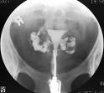
HSG report – uni/bi cornuate uterus
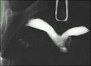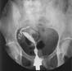
HSG report – hydrosalpinx
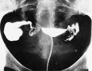

3.Laproscopic chromopertubation
- Invasive procedure…
- Lap. visualization of pelvis, organs & injection of Methylene Blue dye through Cx & it’s spill is visualized..
- Indication : - Abnormal HSG finding
- Failure to conceive after 6 month of Rx
- Unexplained infertility & age above 35 yr
- Prior to tubal microsurgery
- Also used as Therapeutic in adhesion & fimbrial block,ovarian drilling
- Time :
In seceretory phase…
recent corpus leuteum may visualize
Endometrial biopsy can taken..
- Method :
double puncture method used & pelvic organ visualized specially fimbrial end & it’s relation..
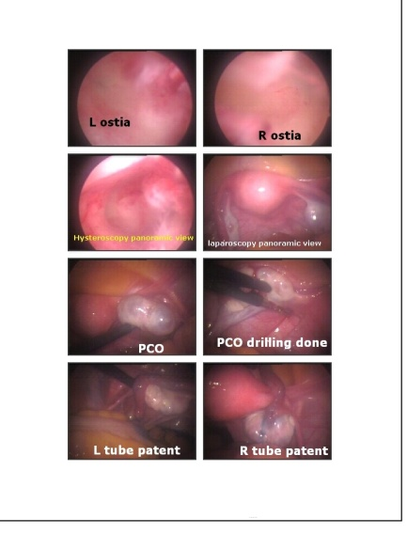

4.SonosalpingoGraphy
- Popularized by G.Alllahabadiya as ‘ SION ‘ Test
- Principle : Normal saline pushed in u.cavity with pediatric foley’s catheter & bulb inflated above int.os which prevents leakage..
- Nearly 200 ml saline needed…
- Inj. of small amount air help in visualization of air bubble movement
- Fluid in Pouch of Douglas detected
- Advantage : Non-invasive
No radiation exposure
Tubal pathology can be detected
Uterine malformation, synechia or polyp can be detected
5.Transvaginal falloposcopy
- Visualize lumen of tubes…
- Therapeutic for Medial end blockage due to adhesion or mucous plug..
6.Ampullary & fimbrial Salpingoscopy
- To Study mucosa of F. tube in deciding between tubal microsurgery & IVF..
- Colour Doppler Ultrasound – Under study
7.Descending Test
- Starch injected in pouch of Douglas, starch present in cervical mucosa 24 hr later indicate patency…
- Advnt. Of Endoscopy..
Minimal invasive
Early recovery & Early discharge
less post op. Pain
Better field of vision
less chance of adhesion
- Dis advnt…
Equipment , Skill, GA, Complications

